**“My checkpoints“**

* *How does the web work*?

*How the web works* provides a simplified view of what happens when you view a webpage in a web browser on your computer or phone.

This theory is not essential to writing web code in the short term, but before long you'll really start to benefit from understanding what's happening in the background.

[**Clients and servers**](https://developer.mozilla.org/en-US/docs/Learn/Getting_started_with_the_web/How_the_Web_works#clients_and_servers)

Computers connected to the web are called **clients** and **servers**. A simplified diagram of how they interact might look like this:

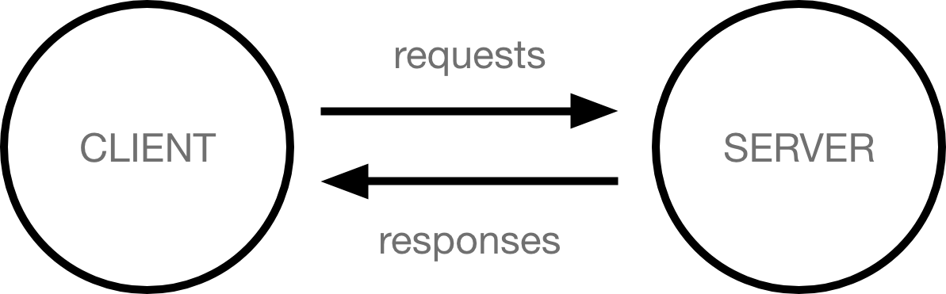

* Clients are the typical web user's internet-connected devices (for example, your computer connected to your Wi-Fi, or your phone connected to your mobile network) and web-accessing software available on those devices (usually a web browser like Firefox or Chrome).
* Servers are computers that store webpages, sites, or apps. When a client device wants to access a webpage, a copy of the webpage is downloaded from the server onto the client machine to be displayed in the user's web browser.

[**The other parts of the toolbox**](https://developer.mozilla.org/en-US/docs/Learn/Getting_started_with_the_web/How_the_Web_works#the_other_parts_of_the_toolbox)

The client and server we've described above don't tell the whole story. There are many other parts involved, and we'll describe them below.

For now, let's imagine that the web is a road. On one end of the road is the client, which is like your house. On the other end of the road is the server, which is a shop you want to buy something from.



In addition to the client and the server, we also need to say hello to:

* **Your internet connection**: Allows you to send and receive data on the web. It's basically like the street between your house and the shop.
* **TCP/IP**: Transmission Control Protocol and Internet Protocol are communication protocols that define how data should travel across the internet. This is like the transport mechanisms that let you place an order, go to the shop, and buy your goods. In our example, this is like a car or a bike (or however else you might get around).
* **DNS**: Domain Name Servers are like an address book for websites. When you type a web address in your browser, the browser looks at the DNS to find the website's real address before it can retrieve the website. The browser needs to find out which server the website lives on, so it can send HTTP messages to the right place (see below). This is like looking up the address of the shop so you can access it.
* **HTTP**: Hypertext Transfer Protocol is an application [protocol](https://developer.mozilla.org/en-US/docs/Glossary/Protocol) that defines a language for clients and servers to speak to each other. This is like the language you use to order your goods.
* **Component files**: A website is made up of many different files, which are like the different parts of the goods you buy from the shop. These files come in two main types:
  + **Code files**: Websites are built primarily from HTML, CSS, and JavaScript, though you'll meet other technologies a bit later.
  + **Assets**: This is a collective name for all the other stuff that makes up a website, such as images, music, video, Word documents, and PDFs.
* *What*do you need*to be a web developer?*

# **How to become a web developer**

With recent studies showing there is a significant - and growing - skills shortage across the digital sphere, it is imperative that this critical knowledge gap within the industry is addressed.

More traditional jobs are ceasing to exist, so training in an industry that is proliferating is the ideal way to ensure you are employed well into the future.

The British Chamber of Commerce found that more than [75% of UK businesses face a digital skills shortage](http://www.britishchambers.org.uk/press-office/press-releases/bcc-shortage-of-digital-skills-hampering-business-productivity-and-growth.html), so a career in web development can be lucrative, as well as flexible.

Businesses based across Hertfordshire are in need of experienced digital professionals, making this the ideal time to consider a career in web development.

Whether you’re choosing your future school exam options, you’ve just graduated or you wish to retrain in a futureproof industry, by following the steps in our essential guide you can begin to plan your career as a web developer. Alternatively, contact us today for any [web design Hertfordshire](https://tutch.co.uk/)-related questions and queries.

* *What is the role of a web developer ?*

**Web Developer Job Responsibilities:**

The role is responsible for designing, coding and modifying websites, from layout to function and according to a client’s specifications. Strive to create visually appealing sites that feature user-friendly design and clear navigation.

**Web Developer Job Duties:**

* Regular exposure to business stakeholders and executive management, as well as the authority and scope to apply your expertise to many interesting technical problems.
* Candidate must have a strong understanding of UI, cross-browser compatibility, general web functions and standards.
* The position requires constant communication with colleagues.
* Experience in planning and delivering software platforms used across multiple products and organizational units.
* Deep expertise and hands on experience with Web Applications and programming languages such as HTML, CSS, JavaScript, JQuery and API’s.
* Deep functional knowledge or hands on design experience with Web Services (REST, SOAP, etc ..) is needed to be successful in this position.
* Strong grasp of security principles and how they apply to E-Commerce applications.

**Web Developer Skills and Qualifications:**

JavaScript, JQuery, HTML, HTML5, CSS, CSS3, Web Programming Skills, E-Commerce, Teamwork, Verbal Communication, cross-browser compatibility, Web User Interface Design (UI), Security Principles, Object-Oriented Design, Web Services (REST/SOAP), Multimedia Content Development, API’s